Sample Letters

On the following pages you will find sample letters to help get you started contacting schools. We hope this gives you a good place to start with your letters. You are able to use them as they are and just add the details relating to you and your classes, amend them a little or even read them and take the sections, images and logos you like to produce you own.

You will find the following samples:

- Introduction letter to a nursery
- An example service level agreement with a nursery
- Letter to nursery parents
- Letter to nursery parents with a reply slip
- Introduction letters to head teachers and principals
- Letter for primary parents
- Letter for primary parents with reply slip
- Letter for primary parents (Scotland) – designed to offer Language Membership Pack

Business Name

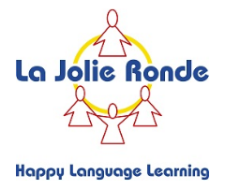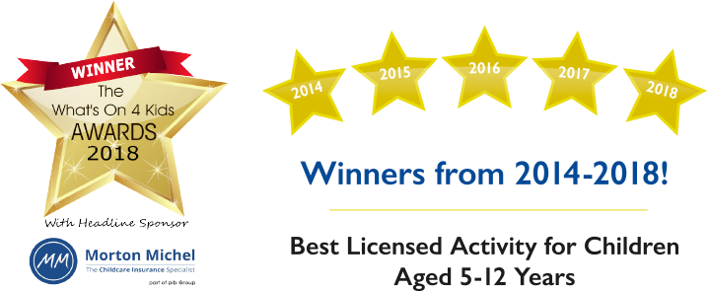

Address
Address
Telephone number
Email
www.lajolieronde.co.uk

Date

Dear ///,

Subject: Language classes for under 5’s

I’m a local French mum/dad who is launching new extracurricular French/Spanish classes for children aged 3-5 in the area; I have seen 1st hand how well children learn languages at this age. I’d be very interested to discuss the opportunities with you.

I’d love to offer you and your nursery a FREE nursery taster session, so that you and the children can experience the classes in action. I can pop in at any time.

I’m teaching the Award Winning La Jolie Ronde Programmes; for 0-12’s, they have been teaching children for over 30 years and parents voted them the “Best National Activity for 5-12 years olds” winning it for 5 years running, from 2014-2018 in the What’s on 4 Awards. I truly believe young children have the ability to quickly pick up a foreign language and learning a language at this young age is an excellent preparation for what is to come at secondary school level.

My classes provide:

- Public liability insurance
- DBS certificate and registered with the update service
- A unique and well-established structured language course
- An authentic accent for the children to pick up
- Small classes with children of similar age
- Conversation, basic grammar, games, role-plays, rhymes and stories
- An awareness of the foreign country , its geography and its culture
- Termly reports on children’s progress

What happens next?
I would love to discuss the opportunities I could offer your nursery and your children and discuss the offer of a FREE taster session, so that you and the children can experience the classes in action. I hope you won’t mind me contacting you next week to discuss this further.

In the meantime, please do not hesitate to contact me should you have any questions.

Yours sincerely,

Licensee Name
Owner of Business name
Teaching under licence from La Jolie Ronde
Licence no. xxxxxx

Sample service level agreement

- Sally Smith, Trading as ABC Languages, teaching under licence with La Jolie Ronde. Licence number: 0123456.
1 Play Street,
Toy Town,
Kiddiminster,
Childshire.

And

- Little Bears Nursery, 1 High Street, Toy Town, Kiddiminster, Childshire.

We have agreed that ABC Languages will provide French and Spanish classes at Little Bears Nursery on Tuesdays between 10am and 11am, commencing on 14th January 2015.

We have agreed that Little Bears Nursery will pay ABC Languages £25.00 per hour. Little Bears Nursery will pay ABC Languages on the 15th of the month on receipt of their invoice on the 1st of every month.

Termination: If either party wishes to terminate this agreement they will give a minimum of 10 week notice in writing.

Signed on behalf of ABC Languages:
Print Name: Sally Smith
Date:

Signed on behalf of Little Bears Nursery:

Print name: Mrs. A. Manager

Date:
Business Name
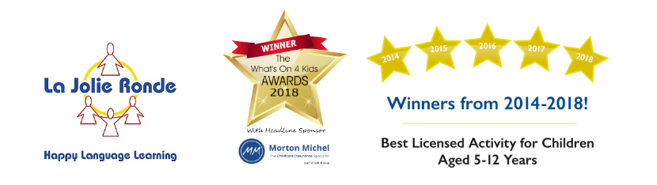

Address
Address
Telephone number
Email
www.lajolieronde.co.uk

How could your family and your child benefit on your a holiday abroad,
if they could speak the local language?

I’m offering your child the chance to join my new French and Spanish classes and learn that skill from me Sarah here at insert nursery name; I’m also in other community venues. I’m a fluent French and Spanish speaking mum of 2 who loves learning languages. I’m not alone in my passion to help children learn and love to become French and Spanish speakers; I’m teaching the multi-award winning La Jolie Ronde programmes.
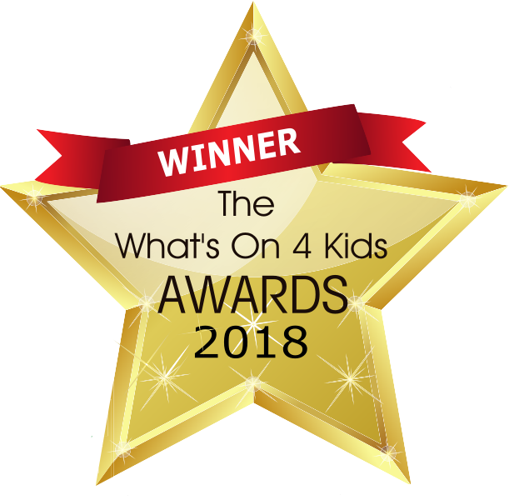
They have won the 2018 “What’s-on-4-Awards”, as voted for by parents for “Best National Activity for 5-12 years olds”, they have won it 5 years running. AND its unique teaching method is for under 5’s too!

Would you like to come and see for yourself what and how your children will learn in a FREE taster session for you and your child to attend? We only have 8 places available per class.

To start your child’s journey through the wonderful world of learning French and/or Spanish, all they need is their Language Pack, which includes:


Language Pack
- 10 x 30 Minute Lessons
- Pupil Activity Book and Music App Access
- Pupil Book Bag
- Certificate and Medal Presentation
- Regular Newsletters
- Progress Report
- Access to our Parent Facebook Group
- Access to Holiday Activity Sessions
- Parent Guides
- No Hidden Costs or Membership Fees
Pack cost: £/€XX.XX – (terms 2 and 3 are £/€XX.XX each for 10 lessons per term)

The programme is designed to enhance your children’s learning skills and to challenge them, in order for them to excel at the language and develop their language confidence and skills to the highest level possible. If you have any questions please let me know.

If you would like to find out more about our classes or book a place for your child on our next FREE session please:

SEND YOUR CHILD’S NAME

CALL OR TEXT: insert number
EMAIL: insert email address
Closing date: XX/XX/XX
Business Name

Address
Address
Telephone number
Email
www.lajolieronde.co.uk

How could your family and your child benefit on your a holiday abroad,
if they could speak the local language?

I’m offering your child the chance to join my new French and Spanish classes and learn that skill from me Sarah here at insert nursery name; I’m also in other community venues. I’m a fluent French and Spanish speaking mum of 2 who loves learning languages. I’m not alone in my passion to help children learn and love to become French and Spanish speakers; I’m teaching the multi-award winning La Jolie Ronde programmes.
They have won the 2018 “What’s-on-4-Awards”, as voted for by parents for “Best National Activity for 5-12 years olds”, they have won it 5 years running. AND its unique teaching method is for under 5’s too!

Would you like to come and see for yourself what and how your children will learn in a FREE taster session for you and your child to attend? We only have 8 places available per class.

To start your child’s journey through the wonderful world of learning French and/or Spanish, all they need is their Language Pack, which includes:
Language Pack
- 10 x 30 Minute Lessons
- Pupil Activity Book and Music App Access
- Pupil Book Bag
- Certificate and Medal Presentation
- Regular Newsletters
- Progress Report
- Access to our Parent Facebook Group
- Access to Holiday Activity Sessions
- Parent Guides
- No Hidden Costs or Membership Fees
Pack cost: £/€XX.XX – (terms 2 and 3 are £/€XX.XX each for 10 lessons per term)

The programme is designed to enhance your children’s learning skills and to challenge them, in order for them to excel at the language and develop their language confidence and skills to the highest level possible. If you have any questions please let me know.

If you would like to find out more about our classes or book a place for your child on our next FREE session please:

Name of child:…………………….................................……................Date of Birth:…………...................
Name of parent/carer:………..…………………………...................................................................………
Contact Telephone No:…………………………...............
E-mail:……………………………................................................……....................................................…
Return date: XX/XX/XX

Business Name

Address 1
Address 2
Telephone number
Email
www.lajolieronde.co.uk

Subject: Hiring a room for Extra-Curricular French and Spanish clubs

Dear (Head teacher), Date

I am interested in hiring a room at your school for my French and Spanish classes for children. Is this something you would be able to help me with?

I’m licensed to teach French and Spanish through the country’s leading extracurricular languages provider La Jolie Ronde. They have won the 2018 What’s-on-4-Awards for “Best National Activity for 5-12 years olds”. They have won it 5 years running, it’s voted for by parents and they also currently supply language resources and programmes in over 60% of UK schools.

What I provide:

- £10M Public liability insurance
- DBS certificate and registered with the update service
- Safeguarding Certificate
- Behaviour Management Certificate
- An award-winning extracurricular programme for your school & pupils
- Additional school income for every week the school is open
- Free taster lesson for every child

I can take a call anytime on (insert number) or if you’d prefer to email: (insert email) to discuss this further. If you’d prefer I speak with another member of staff, please let me know.

Thank you for your time and I look forward to hearing from you.

Yours sincerely,
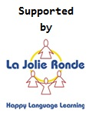

Licensee Name
Owner of Business name
Teaching under licence from La Jolie Ronde
Licence no. xxxxxx

Business Name

Address
Address
Telephone number
Email
www.lajolieronde.co.uk

How could your family and your child benefit on your next holiday abroad,
if they could speak the local language?

I’m offering your child the chance to join my new French and Spanish classes and learn that skill from me Sarah here at insert school name; I’m also in other community venues. I’m a fluent French and Spanish speaking mum of 2 who loves learning languages. I’m not alone in my passion to help children learn and love to become French and Spanish speakers; I’m teaching the multi-award winning La Jolie Ronde programmes.
They have won the 2018 “What’s-on-4-Awards”, as voted for by parents for “Best National Activity for 5-12 years olds”. They have won it 5 years running!

Would you like to come and see for yourself what and how your children will learn in a FREE taster session for you and your child to attend? We only have 12 places available per class.

To start your child’s journey through the wonderful world of learning French and Spanish, all they need is their Language Pack, which includes:
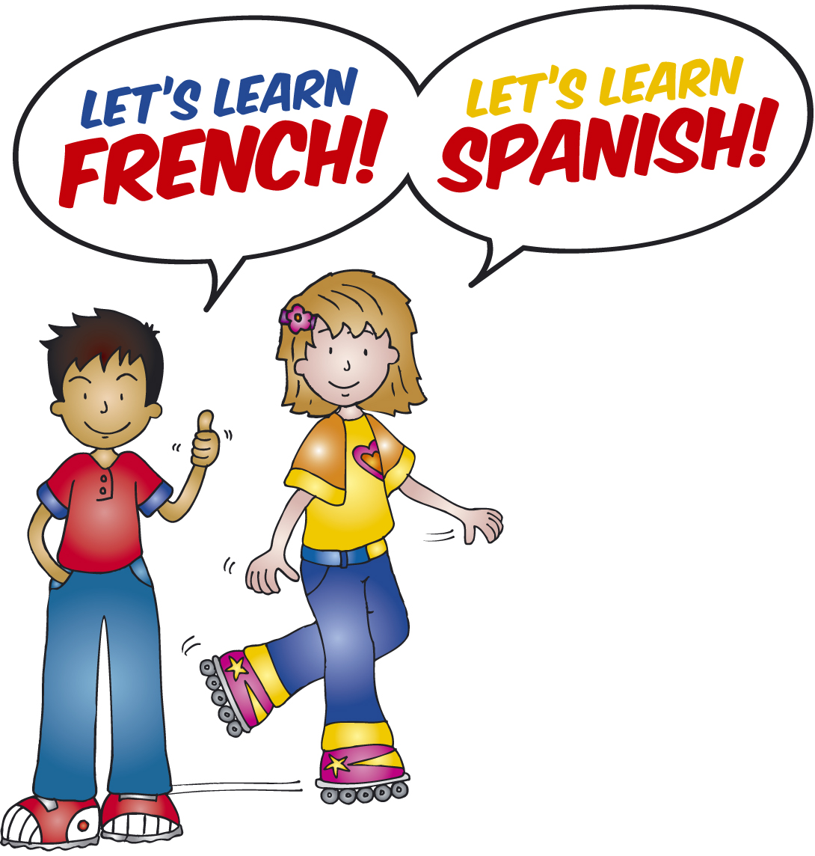

Language Pack
- 10 x 30 Minute Lessons
- Pupil Activity Book and Music App Access
- Pupil Book Bag
- Certificate and Medal Presentation
- Regular Newsletters
- Progress Report
- Access to our Parent Facebook Group
- Access to Holiday Activity Sessions
- Parent Guides
- No Hidden Costs or Membership Fees
Pack cost: £/€XX.XX – (terms 2 and 3 are £/€XX.XX each for 10 lessons per term)

The programme is designed to enhance your children’s learning skills and to challenge them, in order for them to excel at the language and develop their language confidence and skills to the highest level possible. If you have any questions please let me know.

If you would like to find out more about our classes or book a place for your child on our next FREE session please:
SEND: 1. YOUR CHILD’S NAME .2 CLASS TEACHER

CALL OR TEXT: insert number
EMAIL: insert email address
Closing date: XX/XX/XX
Business Name

Address
Address
Telephone number
Email
www.lajolieronde.co.uk

How could your family and your child benefit on your next holiday abroad,
if they could speak the local language?

I’m offering your child the chance to join my new French and Spanish classes and learn that skill from me Sarah here at insert school name; I’m also in other community venues. I’m a fluent French and Spanish speaking mum of 2 who loves learning languages. I’m not alone in my passion to help children learn and love to become French and Spanish speakers; I’m teaching the multi-award winning La Jolie Ronde programmes.
They have won the 2018 “What’s-on-4-Awards”, as voted for by parents for “Best National Activity for 5-12 years olds”. They have won it 5 years running!

Would you like to come and see for yourself what and how your children will learn in a FREE taster session for you and your child to attend? We only have 12 places available per class.

To start your child’s journey through the wonderful world of learning French and Spanish, all they need is their Language Pack, which includes:

Language Pack
- 10 x 30 Minute Lessons
- Pupil Activity Book and Music App Access
- Pupil Book Bag
- Certificate and Medal Presentation
- Regular Newsletters
- Progress Report
- Access to our Parent Facebook Group
- Access to Holiday Activity Sessions
- Parent Guides
- No Hidden Costs or Membership Fees
Pack cost: £/€XX.XX – (terms 2 and 3 are £/€XX.XX each for 10 lessons per term)

The programme is designed to enhance your children’s learning skills and to challenge them, in order for them to excel at the language and develop their language confidence and skills to the highest level possible. If you have any questions please let me know.

If you would like to find out more about our classes or book a place for your child on our next FREE session please:

Name of child:…………………….................................……..................................................................…
School Year:……………………...........................Date of Birth:…………................................…..…........
Name of parent/carer:………..…………………………...................................................................………
E-mail:……………………………................................................……....................................................…
Contact Telephone No:…………………………............... Closing date: XX/XX/XX
Business Name

Address
Address
Telephone number
Email
www.lajolieronde.co.uk

How could your family and your child benefit on your next holiday abroad,
if they could speak the local language?

I’m offering your child the chance to join my new French and Spanish club and learn that skill from me Sarah here at insert school name; I’m also in other community venues. I’m a fluent French and Spanish speaking mum of 2 who loves learning languages. I’m not alone in my passion to help children learn and love to become French and/or Spanish speakers; I’m teaching the multi-award winning La Jolie Ronde programmes.
They have won the 2018 “What’s-on-4-Awards”, as voted for by parents for “Best National Activity for 5-12 years olds”. They have won it 5 years running!

Would you like to come and see for yourself what and how your children will learn in a FREE taster session for you and your child to attend? We only have 12 places available per session.

To start your child’s journey through the wonderful world of learning French and/or Spanish, all they need is their Language Membership Pack, which includes:
Language Membership pack
- 10 x 30 Minute club sessions
- Pupil Activity Book and Music App Access
- Book Bag
- Certificate and Medal Presentation
- Regular Newsletters
- Progress Report
- Access to our Parent Facebook Group
- Priority booking for Holiday Activity Sessions
- Parent Guides
- No Hidden Costs
Pack cost: £/€XX.XX – (terms 2 and 3 membership only £XX.XX each)

La Jolie Ronde” award winning programmes have been written and designed specifically for young learners taking into account the experiences and outcomes of the Curriculum for Excellence thus ensuring that parents know the level that their children are working towards. Additionally, they offer excellent continuity meaning that children have the opportunity to effortlessly progress from nursery through to secondary school and beyond.

If you would like to find out more about our club or book a place for your child on our next FREE session please:
SEND: 1. YOUR CHILD’S NAME .2 CLASS TEACHER

CALL OR TEXT: insert number
EMAIL: insert email address
Closing date: XX/XX/XX

